**GUIDE TO ACCESSING THE OCCUPATIONAL HEALTH ONLINE PORTAL**

**PRE-PLACEMENTS**

1. Go to the link for the Portal <https://rbch.eopas.co.uk/>
2. If you have not accessed the portal before, click on “Sign up now”

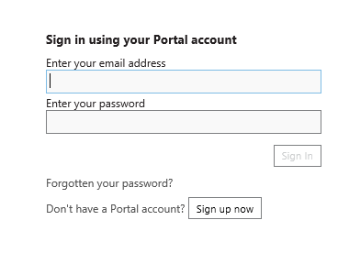

1. You will now be directed to enter your email address.

* **Company reference –** this will be dependent on the position you are applying for. Please select the code for the site at which you will be based:

**Bournemouth and Christchurch sites – M500F10A**

**Poole and Alderney sites – P400D67E**

* You will then need to create a password which has a capital letter and a character (please ensure it is memorable)
* Please then add in a security question with an answer (also ensure this is memorable)
* The Captcha field should then be completed
* Then press CONTINUE

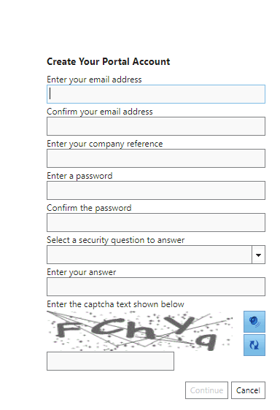

1. Once you have completed your details and password, you will then need to go to the message sent to your email address to verify your account.

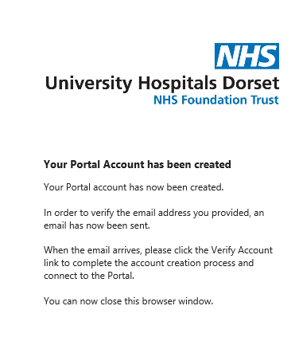

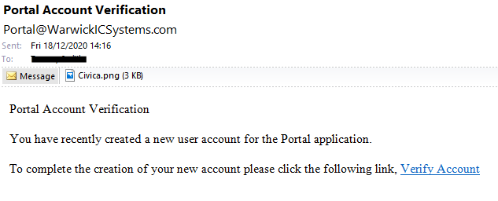

1. Once you have verified your account you will then be prompted to re-enter your email and password to access the Portal.

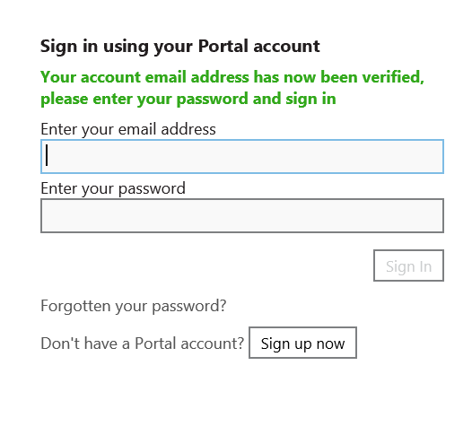

1. Once you have signed into the portal, you will then be prompted to enter your personal details (company reference should be already be populated from your sign up) Please ensure all mandatory fields are entered along with your NI number if you know it and click Next.

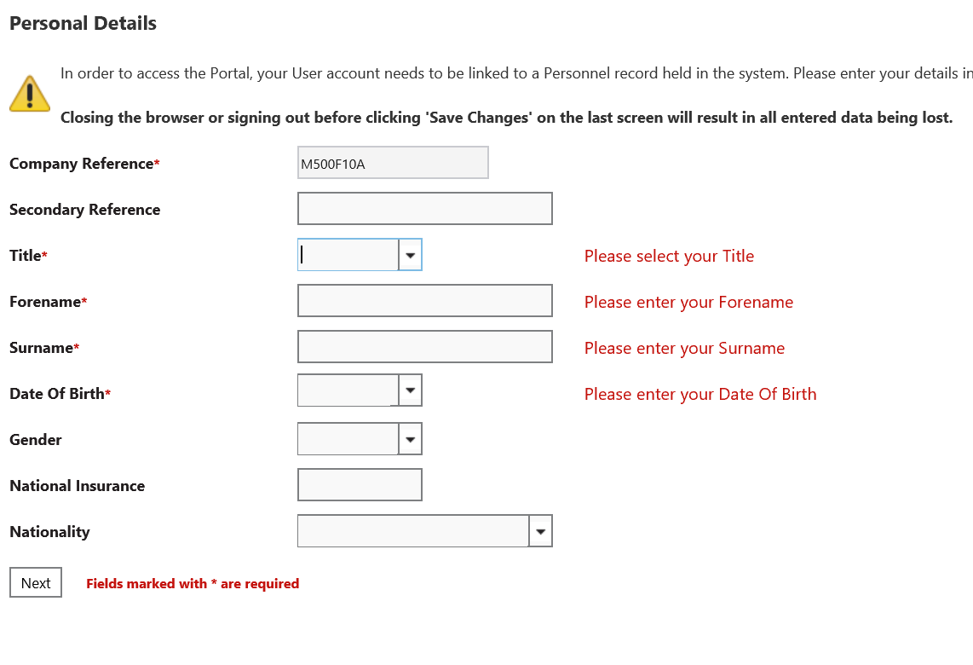

1. You should then complete your contact details ensuring we have your most up to date address, postcode and mobile phone number. The email address should automatically populate with the email address entered when signing up.

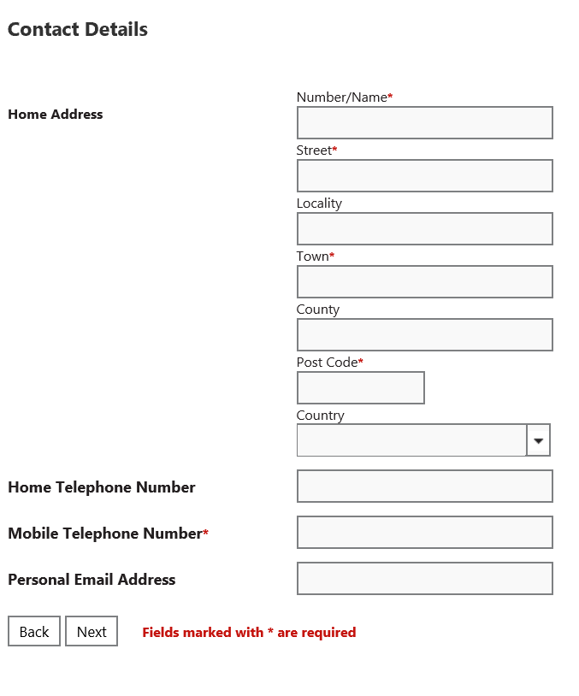

1. Your employment details will then appear with pre-populated Trust name and site location (this will pick up from your company reference) Please ensure your correct proposed site location is showing, then Save Changes.

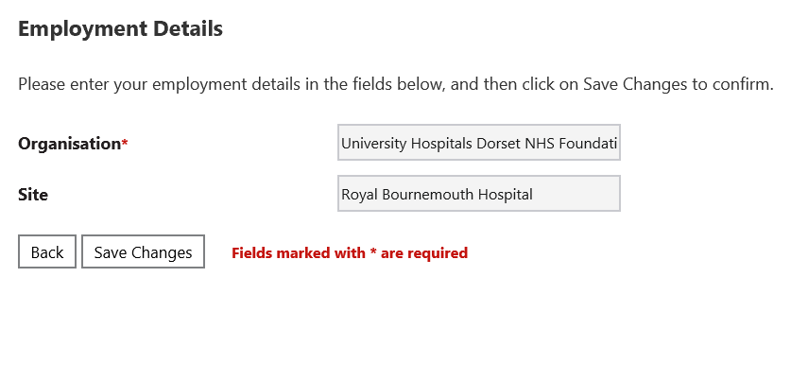

1. You will then see the main page of the Portal:

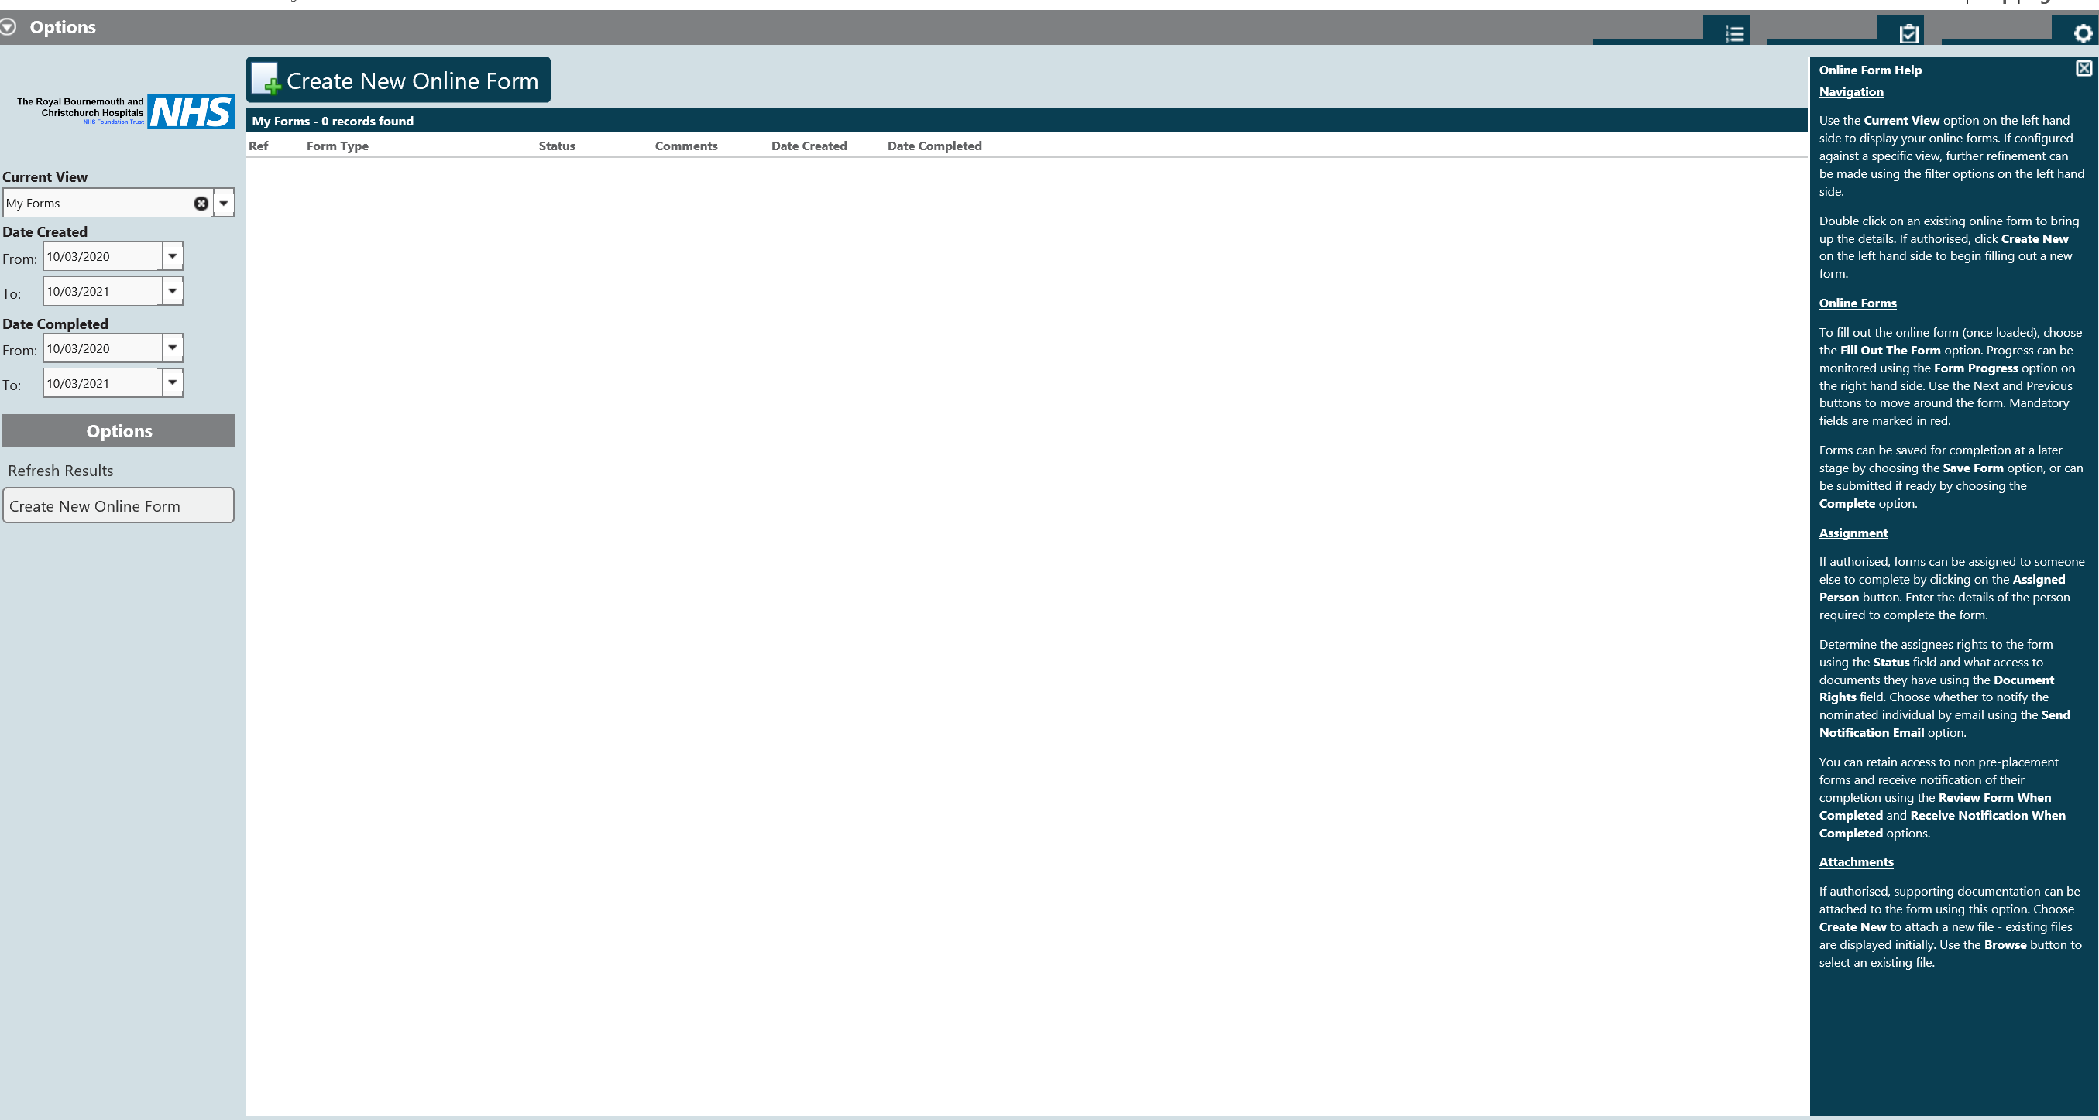

1. To generate a new form click on the top button, Create New Online Form or alternatively you can also use the same button on the left of the screen.

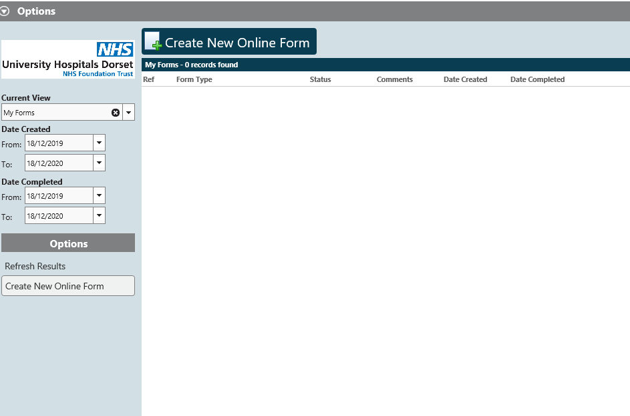

1. On the right of the main page, you will find a Help section. This can be turned on or off by using the Help llink at the top of the page next to Sign Out.

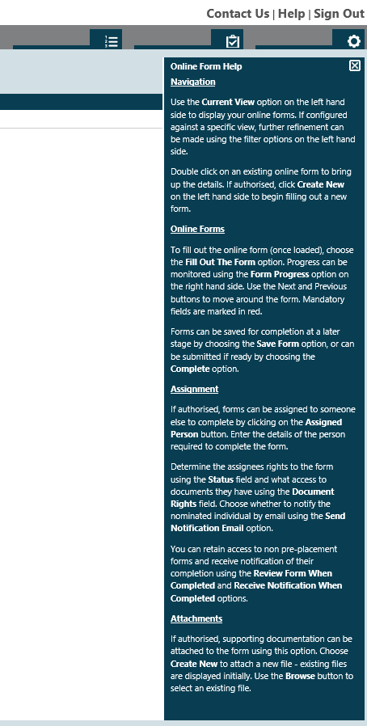

1. Once you have selected Create new online form, you will be able to select Pre Placement Questionnaire from the drop down on Form Type.

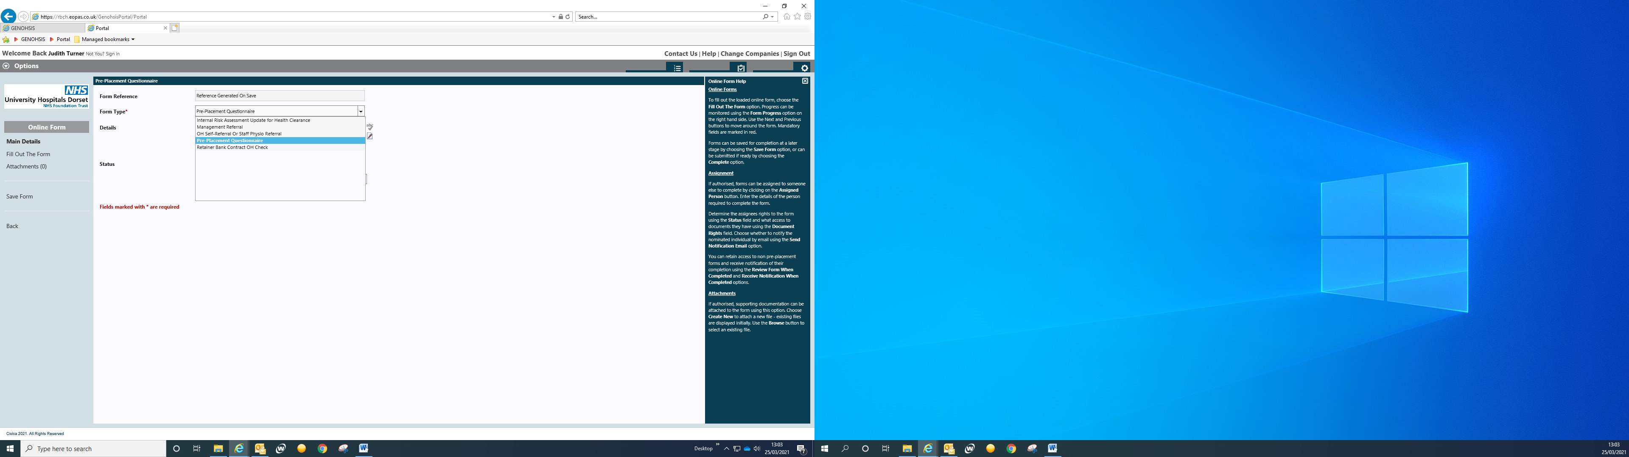

1. Complete all information requested and submit form – please ensure all attachments requested are attached before submission. It is possible to save and come back at a later date, but OH will not receive the form until it is finally submitted.
2. Once submitted all forms will show on the main page and are accessible but not amendable.

If you have any issues with the use of the Portal for Occupational Health – please contact us on [Helpline.OHPortal@uhd.nhs.uk](mailto:Helpline.OHPortal@uhd.nhs.uk)

Please note that OH will NOT be able to assist with the Portal by phone.